Galvanic Cells
FlexBooks® 2.0 > CK-12 Chemistry For High School > 23.3 Galvanic Cells
What made it twitch?
Luigi Galvani (1737-1798) was an Italian physician and scientist who did research on nerve conduction in animals. His accidental observation of the twitching of frog legs when they were in contact with an iron scalpel while the legs hung on copper hooks led to studies on electrical conductivity in muscles and nerves. He believed that animal tissues contained an “animal electricity” similar to the natural electricity that caused lightning to form.
Galvanic Cells
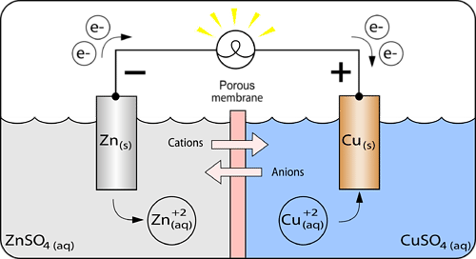
A galvanic cell or voltaic cell, is an electrochemical cell that uses a spontaneous redox reaction to produce electrical energy.
Zn|Zn⁺²||Cu⁺²|Cu
Galvanic cell.

A galvanic cell (see Figure above) consists of two separated half-cells. A half-cell is one part of a galvanic cell in which either the oxidation or reduction half-reaction takes place. In the galvanic cell above, the left half-cell is a strip of zinc metal in a solution of zinc sulphate – and this is where oxidation is occurring. The right half-cell is a strip of copper metal in a solution of copper (II) sulphate – and this is where reduction is occurring.
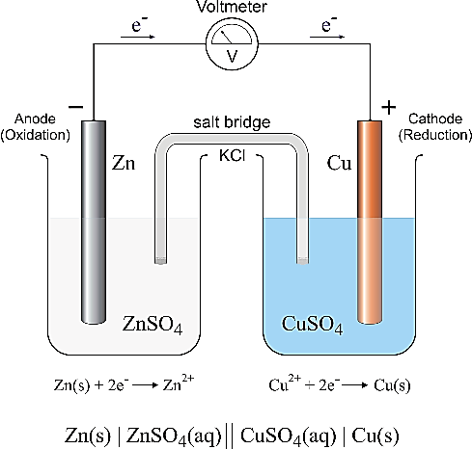
The strips of metal are the electrodes. An electrode is a conductor in a circuit that is used to carry electrons to a non-metallic part of the circuit. The electrodes are placed in electrolyte solutions. A metal wire connects the two electrodes. Although the two half-cells are separated, the cations and anions within them must be able to move in response to the electrochemical reaction and exchange of electrons (charge). To achieve this the two half-cells are either kept in separate containers connected by a salt bridge (which allows ions to migrate from one solution to the other) and is shown on the right, or a porous membrane is placed between the two half-cells (as shown above). The first set up (on the right) is common in laboratories, while the second is common in batteries. The salt bridge allows for the movement of charged ions that provides a complete electric circuit and by balancing the distribution of charge, allows the movement of electrons in the external circuit (wire).

The Electrochemical processes in a Galvanic cell
The various electrochemical processes that occur in a galvanic cell occur simultaneously. It is easiest to describe them in the following steps, using the above zinc-copper cell as an example.
NOTE: Although the following steps are listed in a numerical order, they do occur simultaneously
1. Zinc atoms from the zinc electrode are oxidized to zinc ions. This happens because zinc metal has a lower electronegativity (it is higher than copper on the activity series) and so is oxidized by Cu⁺²_{(aq)}.
Zn_{(s)} → Zn²⁺_{(aq)} + 2e⁻
The electrode at which oxidation occurs is called the anode. The zinc anode gradually diminishes in size as the cell operates due to the loss of zinc metal. The zinc ion concentration in the half-cell increases. Because of the production of electrons at the anode, it is labelled as the negative electrode.
2. The electrons that are generated at the zinc anode travel through the external wire and register a reading on the voltmeter. They continue to the copper electrode.
3. Electrons enter the copper electrode and at the surface of this electrode they are accepted by the copper (II) ions in the solution, reducing the copper ions to copper metal.
Cu²⁺_{(aq)} + 2e⁻ → Cu_{(s)}
This electrode, at which reduction occurs, is called the cathode. The cathode gradually increases in mass because of the production of copper metal on its surface. The concentration of copper (II) ions in the half-cell solution decreases. The cathode is called the positive electrode.
4. Ions move through the salt bridge to maintain electrical neutrality in the cell. In the cell illustrated above, sulphate ions will move from the copper side to the zinc side, and Zinc ions will move towards the copper side to balance the distribution of charges caused by the movement of electrons and the half reactions.
The two half-reactions can again be added to provide the overall redox reaction occurring in the galvanic cell.
Zn_{(s)} + Cu²⁺_{(aq)} → Zn²⁺_{(aq)} + Cu_{(s)}

Activity Series - Thinking question: Why is the zinc oxidised in this galvanic cell, and the copper (ll) ions reduced? Is there a way to predict the reactions that will occur in a galvanic cell? Class discussion on the activity series (next page)

Review
- Rewrite the four electrochemical processes described above in a more general way so it can be applied to any galvanic cell.
- Why are the half-cells physically separated?
- What is the purpose of the porous membrane?

Use the following “blank” Galvanic cells to draw fully labelled diagrams of the galvanic cells formed using (the four metals below are the ones listed in our Success Criteria):
(a) Mg and Cu electrodes and solutions of each metallic ion.
(a) Zn and Fe electrodes and solutions of each metallic ion.
(a) Cu and Fe electrodes and solutions of each metallic ion.
(a) Mg and Zn electrodes and solutions of each metallic ion.
Note that the only information initially provided for you is the direction of electron flow (arrow above the wires) and the activity series on the right.

